|  |  |  |  |  |
| --- | --- | --- | --- | --- |
| **National University of Computer and Emerging Sciences, Lahore Campus** | | | | |
| C:\Users\saif\AppData\Local\Microsoft\Windows\Temporary Internet Files\Content.Word\final design.jpg | **Course:** | **Software Engineering** | **Course Code:** | **CS303** |
| **Program:** | **BS (CS)** | **Semester:** | **Fall 2020** |
| **Duration:** | **90 Minutes (1.5 Hour)** | **Total Marks:** | **45** |
| **Paper Date:** | **21-Oct-20** | **Weight** | **15%** |
| **Section:** | **B,C,D,E** | **Page(s):** | **6** |
| **Exam:** | **Mid I** |  |  |
| **Instruction/Notes:** | 1. Attempt all questions on the question paper. Do not submit any extra sheet, it will not be graded.  2. You are allowed to use a single-sided, hand-written, A-4 size help sheet.  3. State your assumptions clearly | | | |

Name: _______________________________ Roll Number: ______________ Section _____

**Question 1 1+3+5+3+3 = 15 Marks**

Read the following text from a book by Watts Humphrey written in 1989:

*“Requirements change is a continuing problem for software engineering. To have any chance of managing this problem, the software team must follow a few simple rules:*

1. *Implement the product in small incremental steps*
2. *Select each increment to support succeeding increments and/or improve requirements knowledge*
3. *Freeze the requirements for each incremental step before starting design*
4. *When the requirements change during implementation, defer the change to a subsequent increment*
5. *If the changes cannot be deferred, stop work, modify the requirements, revise the plan, and start again on design.*

*These incremental steps, or builds, are aimed at producing running code as soon as possible. The process starts with minimal function and gradually expands until functionally useful level is reached”*

Answer the following questions in the light of above:

**Part a 1 Marks**

If the proposed rules are followed, is the software team following an incremental approach or an evolutionary approach for software development?

Incremental approach

**Part b 3 Marks**

Which limitations of classical waterfall model are being addressed in the given text? List the limitations and clearly relate them with the exact words/rule number of the given text.

The following limitations have been addressed:

1. Long wait before the customer can see a running version of software
2. No guidance on how to handle changes in product requirements
3. Requirements are complete and frozen before the start of design and development

**Part c 5 Marks**

Generate a mapping between the process given in the text and Scrum. Clearly use the Scrum terminology (for example product backlog etc.) and relate the terminology with the text. You may use table or diagram (with boxes and arrows) to show the mapping.

|  |  |  |
| --- | --- | --- |
| **Sr.** | **Terminology in given text** | **Terminology in Scrum** |
| 1 | Increment | Sprint |
| 2 | Rule 2 and 3 | Sprint planning |
| 3 | Freeze requirements for each increment | Sprint Backlog (frozen backlog items) |
| 4 | Defer the change to a subsequent increment | Adding features to product backlog |
| 5 | Rule 5 | Terminating a sprint abnormally |

**Part d 3 marks**

List the things (concepts or points) from the text that are close to the Agile Manifesto

Rule 4 and 5 are close to the part of the manifesto where the manifesto says “Concentrate on responding to change rather than on creating a plan and then following it”

“*These incremental steps, or builds, are aimed at producing running code as soon as possible*” is close to the part of manifesto “Prefer to invest time in producing working software”

**Part e 3 Marks**

Which aspects of Scrum are NOT explicitly covered in the given text? List the aspects.

* Team organization/structure (customer’s continuous involvement)
* Use of backlog (or list of prioritized requirements)
* Daily scrum meetings
* Demos
* No timebox on duration of increment (sprint)

Note: Students may write any 3 of them

Name: _______________________________ Roll Number: ______________ Section _____

**Question 2 5 + 10 = 15 Marks**

We need to write software for an ATM machine. The software will deal with customers’ requests regarding withdrawal of money, change of PIN, checking of account info etc. The software’s programming language is JAVA. It will use a data base management tool, which is ORACLE. The hardware will include an ATM Machine at which the software runs and the software interacts with the ATM card reader and a keypad to get the input. The machine will display messages on screen to keep the customers informed during the processing of customers’ transaction. The software system needs to perform the following functions:

* The system should validate the user entered PIN from the database
* The system should process the amount withdrawal request for the valid ATM card and PIN
* The system should check for the sufficient amount for withdraw from the database
* The system should process PIN change request for a valid ATM card and valid PIN
* The system should process Balance Check request for a valid ATM Card and valid PIN
* The system should process the print receipt request for any successful transaction

Give a level 0 DFD and level 1 DFD for the requirements mentioned above.

[Marks distribution: level 0 DFD (5); level 1 DFD (10).]

Level 0 DFD

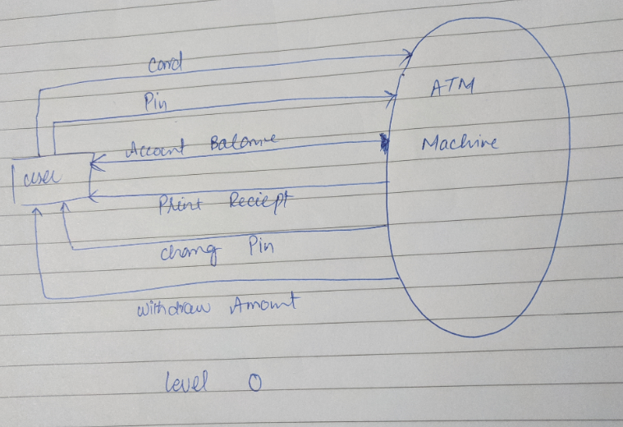

Name: _______________________________ Roll Number: ______________ Section _____

Level 1 DFD

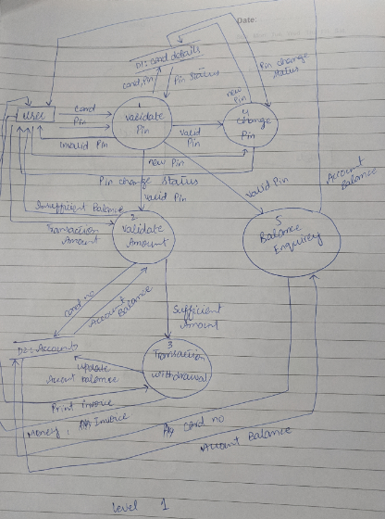

**Question 3 5+5+5 = 15 Marks**

**Part a 5 marks**

In most of the software engineering projects the clients are found to be changing their requirements frequently and the software engineers are found to be dealing with the issue of unstable requirements. The requirements keep on changing even when the major portion of the software has been implemented and tested. The software engineers try to incorporate the required changes even in later phases of software development. Which property of software allows the clients to change the requirements that frequently and lets the software engineers attempt the implementation of the changes?

Name and explain the property

Malleability: software can be easily pressed to any shape i.e. the software can be easily modified to meet any requirements. It leads people to think that the changes in software are easily, whereas in practice, they are not.

Highlight the issues that can arise if the property is exploited

Changes in code might look easy, but respective change in design may not be that easy. The changes may go unmanaged if the property is exploited and changes are made in an undisciplined manner. The unmanaged changes may then lead to difficult maintenance.

**Part b 5 Marks**

Punjab government has sponsored the development of a software application with the name Kisan Dost. The application allows the farmers to get advice on usage of pesticides, water, fertilizer, type of seeds etc. The application also provides the farmers with guidelines to manage certain situations like (worm attack, locust attack etc.). Farmers with smart phones can use the application on their devices whereas the others can visit Kisan Dost centers to use the application through touch screens. Initially the response of farmers was reported to be good but a decline in use of the application has been observed lately. What could be the reason(s)? Initial reports suggest that farmers are not happy with the application. Which mistake(s) by the software engineering team could have resulted in this situation? List the possible mistake(s) and describe it/them in a sentence or two.

Farmers (users) were not consulted during the requirements gathering phase, and their exact needs have not been met.

Part c 5 marks

List the process model that you think will be most appropriate for the following situation. Also, list your reason(s) for choosing a particular model. If you just list the process model without mentioning the reason(s), you will not be awarded any marks.

Situation:

An existing software needs to be developed in a newer and better technology and your company has been assigned this task. The software has been running successfully for a few years and does not require any major changes in its functionalities in the newer technology i.e. same functions that are available in the current version will also exist in the updated version.

Waterfall. Stable and complete requirements, not expected to change